WP 7. Mapping and Clustering Entrepreneurial Skills in TCI
  - CATEKS
Sucsess story
Cateks d.d. is a company specialized in the development, production and sale of special technical fabrics, polyurethane-coated and laminated technical materials, as well as final and ready-made products, which are of high quality. It is the development of quality products that is the key factor for successful business operations and for the achievement of a competitive advantage in the market, and the constant work on improving is their strategy for realizing this advantage. Cateks continuously invests in new equipment that enables the development of new products. Medical program within which is the production of materials waterproofing, antibacterial, antifungal and antidecubitus treatment. Protective program includes the production of a two-layer, three-layer and four-layer laminated materials with breathable membranes production of clothing (waterproof and windproof pants and jackets), and in the footwear industry for the production of special footwear (military and police boots).

Company profile
Cateks is one of the biggest textile producers in the region and one of the oldest in the south Eastern Europe. Thanks to technological development and innovation, today it consists of three production departments: Textile, Polytex and Confection. Such an organisation creates a vertical integrated production and allows for a better control of every phase of production and high degree of technological innovation by combining knowledge and experience of engineers in all production departments that has put Cateks in a position of a producer in technical fabrics and materials of special applications and a higher added value.

INNOVATION PROFILE
Constant investment in innovation has resulted in the development of new technical fabrics for special purposes. Their COMPAGO® Defend represents the top quality of production of special purpose fabrics used for the production of military and police uniforms, such as CORDURA® NYCO materials made of a mixture of polyamide and cotton fibres, a mixture of cotton and polyester, 100% cotton, materials with stainless steel or carbon threads for antistatic properties, or with FR fibres for non-combustibility. Fabrics are finished to meet special properties: Water repellence, Oil repellence, Anti-dirt, creasing, insect protection. A new fabric with significantly improved properties and a concealing pattern that is purposefully designed for the use of the Ministry of Defence, which proves Cateks as a fundamental fabric manufacturer that can follow research and development in this field in the regional, European and global markets. The COMPAGO® PROTECT brand includes high-quality technical materials that protect against weather conditions such as rain and cold, provide protection during work in hazardous conditions when handling flames, oils and petroleum products, when working in explosive atmospheres (when exposed to electrostatic voltage) or in conditions reduced visibility. The materials are divided into three groups: Polyurethane-coated materials, Multilayer materials laminated by dot gluing technology and treated cotton fabrics or
mixtures of cotton and polyester. COMPAGO® Medical are technical materials treated against burns, fungi and bacteria and meet standards such as BS 7175-CRIB 5, EN ISO 12925. The production is carried out in accordance with REACH. The products meet Oeko-tex standard 100, class I, which confirms that the materials they can also be used to make products for children. Their main application is in the production of medical covers for mattresses, pillows and medical aids, as they are pleasant to the touch, antibacterial and provide long-lasting hygiene.
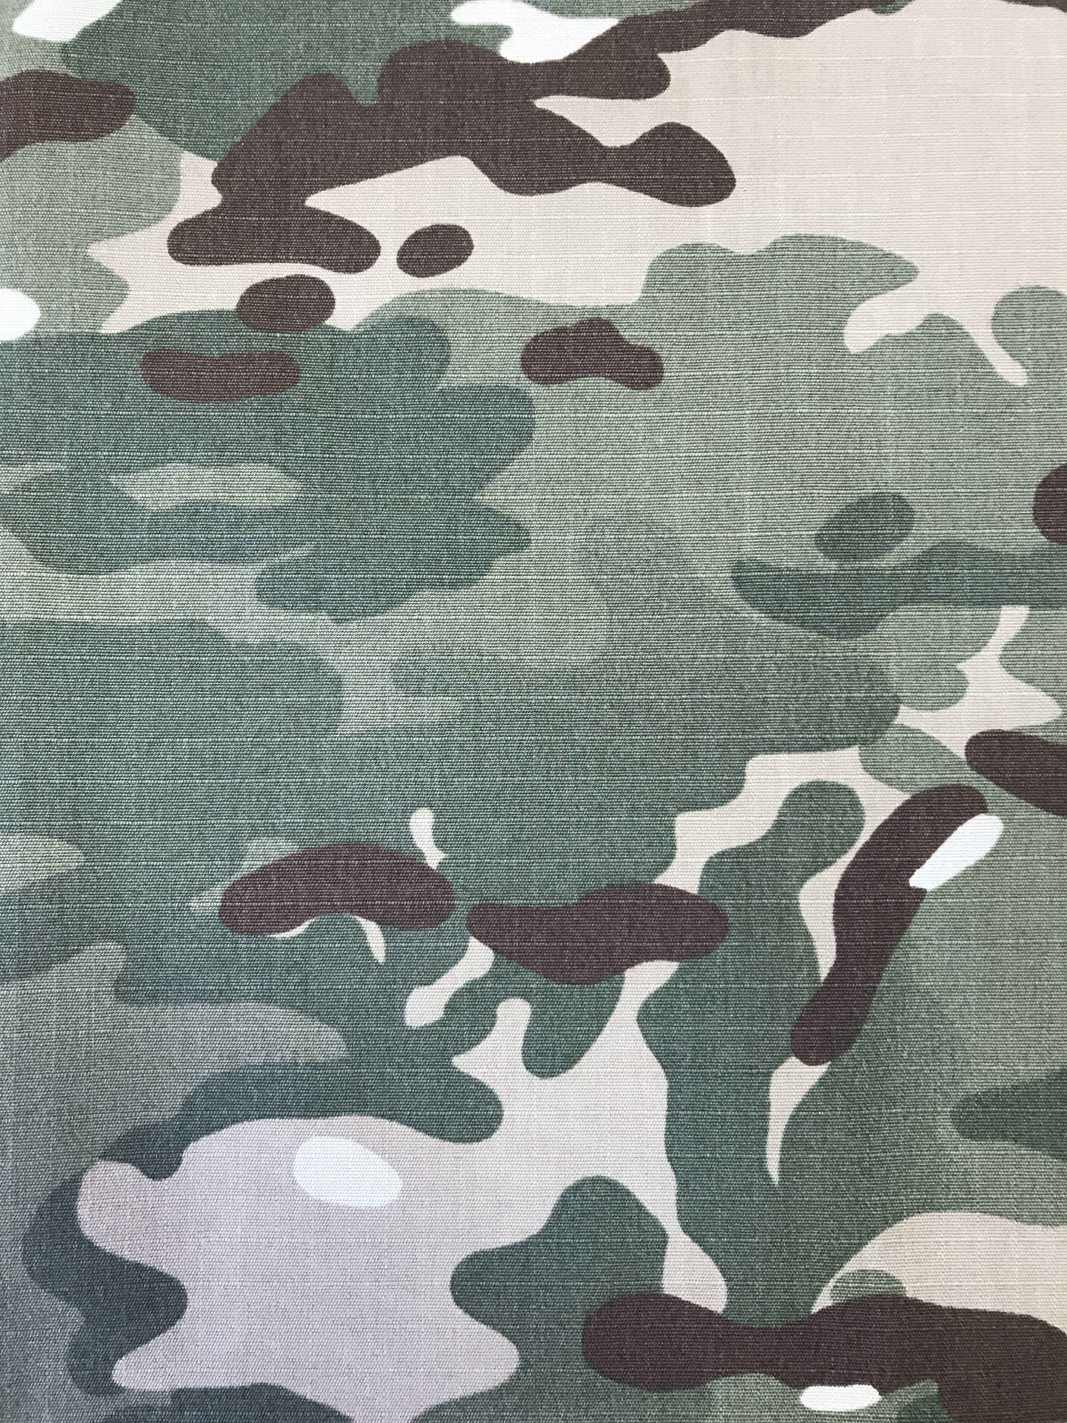

Contact of the Company
Cateks d.d.
Adress: Zrinsko-Frankopanska 25,
40000 Cakovec, Croatia
Contact: info@cateks.hr
Web page: https://cateks.hr/en/

COMPETITIVE ADVANTAGE
In Cateks, the trends in detection and camouflage development are continuously analysed, concluding that today's high-level detection is far ahead of the covering one. The decision to turn to addressing and solving these problems was made, because the preliminary research has already shown that a shift is needed in this segment. Gathering knowledge and experience in 26 years of working with various military units around the world, Cateks has transformed this into a new recognizable product with a completely different way of construction, functioning and approach to solving this problem. Cateks has consulted the best experts in the field of detection, collaborated with many institutions and ultimately protected our results with industrial design for the whole of Europe. So another in ovation is the new camouflage pattern with a whole new perspective on the look of camouflage in a modern combat environment.

Conclusions
Cateks is one of the largest textile companies in the region and one of the oldest in the south eastern part of Europe. Cateks has positioned itself as one of the most important centres for the development and production of high-performance textile materials intended for military and protective purposes. An exceptional example of success that, with advances in technology and an innovative approach, is continuously working on the development of new products. Also, by optimizing existing processes, it increases the utilization of energy and resources, better waste management and thus further contributes to environmental protection.

